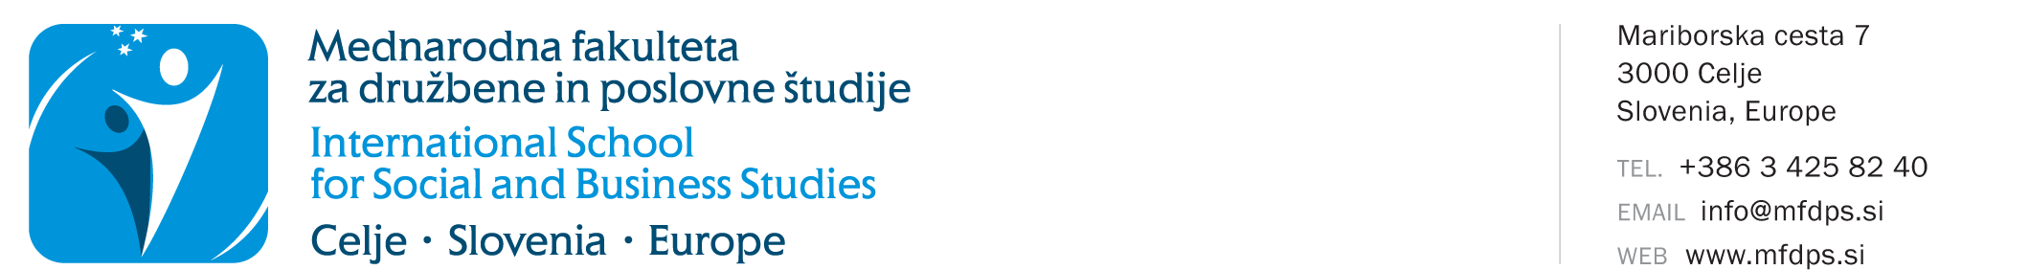
STATEMENT FOR RE-ENROLMENT IN THE YEAR OF STUDY
(for the academic year 2026/2027)

Name and surname:
Student enrolment number:
Address:
Postal code and town/city:
Email address:
Study programme:
Mode of study: |  | full-time |  |  |  | part-time
Last enrolled year of study: |  |  | year
Last enrolled academic year:

The mode of study remains the same as in the last year of enrolment.

STATEMENT

I, the undersigned, declare that I wish to exercise the right to repeat the year of study in the academic year 2026/2027. By signing this form, I declare that I am familiar with the conditions for re-enrolment in accordance with the applicable legislation.

In accordance with the provisions of the Personal Data Protection Act (ZVOP-2) and the General Data Protection Regulation (GDPR), I, the undersigned, consent to and permit my personal data to be stored, processed, transferred and used exclusively for the needs and legally defined obligations of ISSBS, for registration in the ISSBS library and for the use of library system services, for the purposes of statistical processing, contacting, informing and direct marketing activities, free of charge, via postal services, email, SMS and MMS messages, voice and video calls and social networks. I, the undersigned, declare that I authorize ISSBS to use and/or publish photographs and video recordings for its own promotional purposes in various media (e.g., website, Facebook, blog, printed media, Instagram, etc.). ISSBS guarantees that photographs/recordings will be used solely for the stated purposes and never to the personal detriment or insult of the photographed/recorded person. ISSBS undertakes not to disclose my personal data to advertisers for the purposes of carrying out their direct marketing and sales activities.

I, the undersigned, undertake to settle all financial obligations or invoices issued by ISSBS in accordance with the applicable ISSBS Price List of Services. I am aware that, in the event of non-payment, the use of the faculty services may be restricted or disabled.

I, the undersigned, guarantee the accuracy of the data stated on this record sheet.

Datum: |  | Student's signature:

On the basis of a timely submitted Statement for re-enrolment in the year of study and provided that the conditions for repeating the year are met, students will be invited to enrol after 10 September and no later than 30 September.

