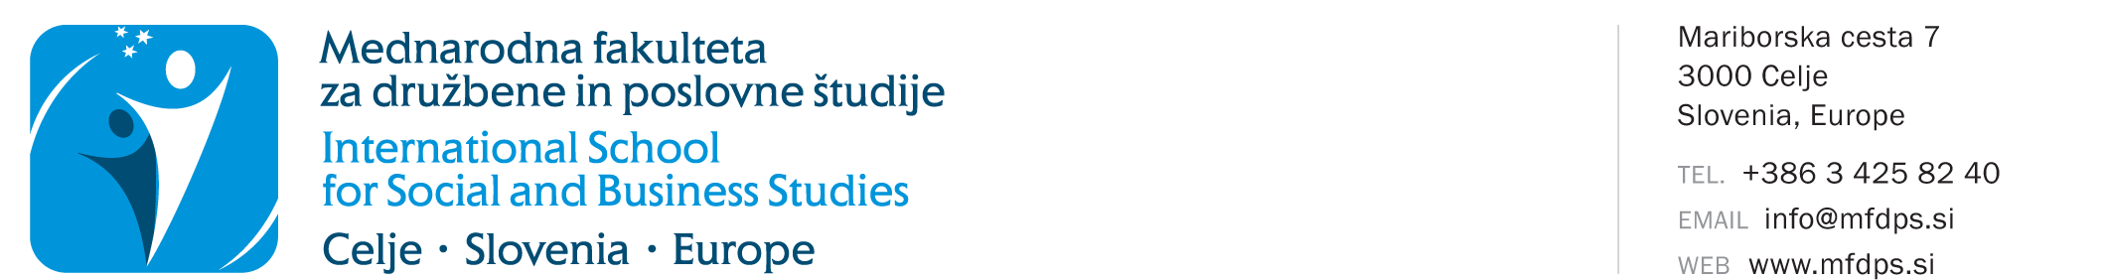
APPLICATION FOR KEEPING RECORDS OF
A PERSON WITHOUT STUDENT STATUS IN THE ACADEMIC YEAR 2026/2027
Personal data
Name and surname
Enrolment number
Study programme | Economy in Contemporary Society  Business in Contemporary Society  Knowledge Management  Managemenbt and Quality in Education  Knowledge Management - doctoral study
Last enrolled year of study when you still had student status | 1st year 2nd year 3rd year  status for 12 months after completion of the last year  extended status for 12 months after completion of the last year
Mode of study | full-time part-time
Permanent residence
Permanent residence address
Postal code and post office
Temporary residence
Temporary residence address
Postal code and post office
Contact details
I wish to receive notices at | permanent residence temporary residence
Telephone number (mobile number)
Email address

I, the undersigned, wish to complete the missing study obligations in the academic year 2026/2027 as a "person without student status".

In accordance with the provisions of the Personal Data Protection Act (ZVOP-2) and the General Data Protection Regulation (GDPR), I, the undersigned, consent to and permit my personal data to be stored, processed, transferred and used exclusively for the needs and legally defined obligations of ISSBS, for registration in the ISSBS library and for the use of library system services, for the purposes of statistical processing, contacting, informing and direct marketing activities, free of charge, via postal services, email, SMS and MMS messages, voice and video calls and social networks. I, the undersigned, declare that I authorize ISSBS to use and/or publish photographs and video recordings for its own promotional purposes in various media (e.g., website, Facebook, blog, printed media, Instagram, etc.). ISSBS guarantees that photographs/recordings will be used solely for the stated purposes and never to the personal detriment or insult of the photographed/recorded person. ISSBS undertakes not to disclose my personal data to advertisers for the purposes of carrying out their direct marketing and sales activities.

I, the undersigned, undertake to settle all financial obligations or invoices issued by ISSBS in accordance with the applicable ISSBS Price List of Services. I am aware that, in the event of non-payment, the use of the faculty services may be restricted or disabled.

I, the undersigned, guarantee the accuracy of the data stated on this record sheet.

Date: |  | Signature:

Send the completed and printed application, together with proof of payment of the enrolment contribution for persons without student status, to the faculty address. If the student has a qualified digital certificate, they may digitally sign the application in PDF format and send it, together with proof of payment of the enrolment fee, to referat@mfdps.si (a scanned signature is NOT valid!).
IMPORTANT: In accordance with the applicable ISSBS Price List, the enrolment contribution for persons without student status is EUR 55. Make the payment to our transaction account SI56 0400 1004 6523 614. When making the payment, use model 00 and enter your enrolment number as the reference.

On the basis of the received application for keeping records of persons without student status and proof of payment, we will assign you a new password for access to the faculty higher education information system.

