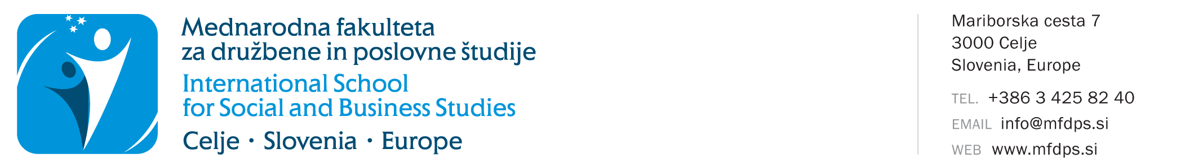

STATEMENT for RE-ENROLLMENT INTO THE STUDY YEAR
(study year 2023/2024)

Name and last name:
Student's registration number:
Address:
Postal code and place:
E-mail:
Study programme:
Mode of study: |  | Full time |  |  |  | Part time
Last year of enrolment: |  |  | year
Last enrolled study year:

The mode of study remains the same as in the last year of enrolment.

STATEMENT

Undersigned below, I declare that I would like to use the right to re-enrol in the study year in the academic year 2023/2024. By signing this form, I declare that I am aware of the terms of re-enrolment. During the previous studies, I did not repeat the study year or change the study programme or course due to non-fulfilment of obligations in the previous study program.

In accordance with the provisions of the Personal Data Protection Act (Official Gazette of the Republic of Slovenia, No. 163/22) and the Personal Data Protection Act (GDPR) I consent and allow my personal data to be stored, processed, transmitted, and used exclusively for the needs, law obligations of ISSBS, and for enrolling in the ISSBS library and using the library system services, for the purpose of statistical processing, contacting, informing, and direct marketing campaigns, free of charge via postal services, e-mail, SMS and MMS messages, voice and video calls, and social networks. I, the undersigned, declare that I authorize ISSBS to use and/or publish photos and videos for their own promotion, in various media (e.g. website, Facebook, blog, print media, Instagram, etc.). The ISSBS ensures to use the pictures and videos only for the above mentioned purposes and never to use them for harmful purposes. The ISSBS undertakes not to provide my personal information to advertisers for the purposes of carrying out their direct marketing and sales campaigns.

Undersigned below, I undertaking to pay tuition fees (in case the tuition fee is foreseen) and all invoices issued by the faculty by the valid ISSBS price list for services and all other obligations or invoices issued by the faculty. The student is barred from using faculty services in the event of non-payment.

Undersigned, I guarantee the authenticity of the information provided on this record sheet.

Date: |  | Student signature:

On the basis of a timely received Statement for re-enrolment in the study year and upon fulfilment of the conditions for re-enrollment, students will be invited to enrol after September 11, and at the latest by September 29.

