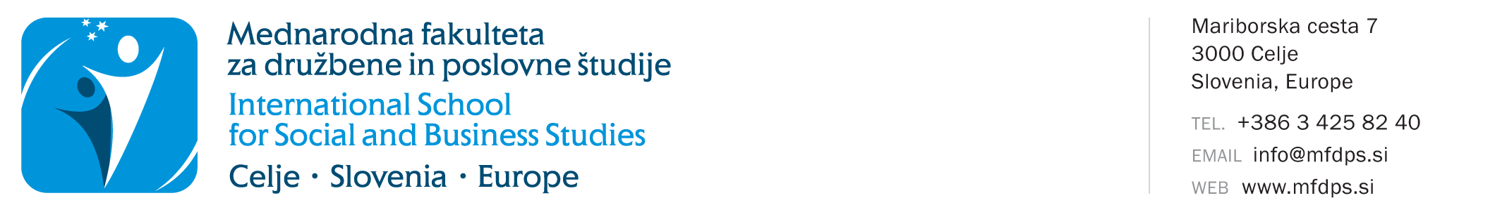
APPLICATION FOR KEEPING RECORD FOR PERSONS
WITHOUT STUDENT STATUS IN THE STUDY YEAR 2022/2023
Personal data
Name and surname
Registration number
Study programme | Economy in Contemporary Society  Business in Contemporary Society  Knowledge Management  Management and Quality in Education  Knowledge Management – doctoral study
Last enrolled study year when you still had a student status | 1. year 2. year 3. year  status 12 months after ending the last year  extended status 12 months after ending the last year
Mode of study | full-time part-time
Permanent Residence
Address
Postal code and place
Temporary Residence
Address
Postal Code and place
Contact data
I want to receive notifications to my | permanent residence temporary residence
Telephone number
E-mail
Undersigned below, I wish to perform the missing obligations as a person without student status in the study year 2022/2023.
In accordance with the provisions of the Personal Data Protection Act (Official Gazette of the Republic of Slovenia, No. 94/2007, ZVOP-1-UPB1), and the Personal Data Protection Act (GDPR), I consent and allow my personal data to be stored, processed, transmitted, and used exclusively for the needs, law obligations of ISSBS, and for enrolling in the ISSBS library, for the purpose of statistical processing, contacting, informing, and direct marketing campaigns, free of charge via postal services, e-mail, SMS and MMS messages, voice and video calls, and social networks. I, the undersigned, declare that I authorize the ISSBS to use and/or publish photos and videos for their own promotion in various media (e.g. website, Facebook, blog, printed media, Instagram etc.). The ISSBS ensures to use the pictures and videos only for the above mentioned purposes and never to use them for harmful purposes. The ISSBS undertakes not to provide my personal information to advertisers for the purposes of carrying out their direct marketing and sales campaigns.
Undersigned below, I undertake to pay all invoices issued by the faculty by the valid price list for services. The “person without student status” is barred from using faculty services in the event of non-payment.

Undersigned, I guarantee the authenticity of the information provided on this record sheet.

Date: |  | Signature:

Send the signed and printed application together with the service payment receipt to the address: International School for Social and Business Studies, Mariborska cesta 7, 3000 Celje. On the basis of the received application for keeping record for persons without student status and the payment receipt, you will be given a new password to enter the higher education information system Novis.
IMPORTANT: In accordance with the valid ISSBS pricelist, the administrative costs for keeping record for persons without student status are 48€. Make the payment on the transaction account SI56 0400 1004 6523 614, opened at Nova KBM. When making the payment, refer to model 00 and indicate your registration number as the reference.

