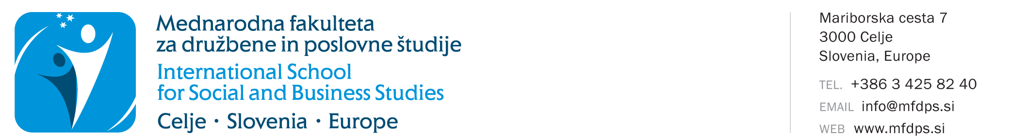

APPLICATION FOR THE CONTINUATION OF STUDIES
AFTER THE INTERRUPTION FOR MORE THAN TWO YEARS
(study year 2021/2022)

Name and surname:
Students' registration number:
Address:
Postal code and place:
E-mail:
Study programme:
Mode of study: |  | full time |  |  | part-time
Last enrolled year of study when still having student status: |  |  | year of study
Last enrolled study year when still having student status

Place and date: |  | Students’ signature:

Send the signed and printed application together with the service payment receipt to the faculty’s address: Mednarodna fakulteta za družbene in poslovne študije, Mariborska cesta 7, 3000 Celje, with the ascription “for the ISSBS Committee for Student Affairs”. The payment receipt has to be attached to the application.

IMPORTANT: In accordance with the valid ISSBS price list, the cost for processing the application by the Committee for Student Affairs is 38 €. Make the payment on the transaction account SI56 0400 1004 6523 614, opened at Nova KBM. When making the payment, refer to model 00 and indicate your registration number as the reference.

Explanation: The Statute of the International School for Social and Business Studies - Paragraphs 2 and 3 of Article 73 of the Statute of the ISSBS (13/2021-Statut):
The study is interrupted on the day a student is withdrawn from a study programme or he/she does not enrol to a higher year or does not take advantage of the enrolment option within twelve months after the end of the last semester.
- If the student interrupts the studies for 24 months or less, he or she can continue and finish it according to the enrolled study program, thus retain the right to complete the study obligations of the programme in which he or she is studying.
- If more than 24 months have passed from the end of the study year in which the student was enrolled the last, the student has to file an application for the continuation of the studies to the Committee. The application and the missing study obligations based on the Decision are charged in accordance with the valid price list.
- If the student has interrupted his studies or repeated a study year and the study program in which he was enrolled has changed before re-enrolment, the student can get obligations recognised which correspond to the curriculum of the changed program, and he or she can be granted to continue and finish the studies under changed study programme by determining additional study obligations in the extent and content that enable the student to achieve the learning outcomes of the changed study program. In these cases, the student, while continuing the studies, is subject of the terms of the changed study programme. The student files an application to the competent committee.
- Before the issue of the diploma certificate, the student must have all financial and other obligations settled.

